Department of Computer Engineering

**Academic Year: 2022-2023 Semester: VIII**

**Subject:-ADSL(CSL8023) Class / Branch / Division:**

**Name :- Roll Number:**

**Date :- Seat-no:-**

**Experiment no.**

**Aim** :Implement Bowley's coefficient of skewness

**THEORY**

Bowley's coefficient of skewness is a measure of the asymmetry of a probability distribution. It is based on the difference between the median and the quartiles of the distribution and ranges between -1 and 1, with negative values indicating a left-skewed distribution, positive values indicating a right-skewed distribution, and 0 indicating a symmetrical distribution

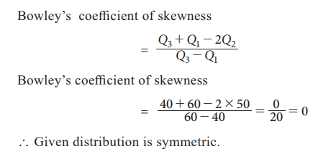

Bowley skewness is a way to figure out if you have a positively-skewed or negatively skewed distribution. One of the most popular ways to find skewness is the Pearson Mode Skewness formula. However, in order to use it you must know the mean, mode (or median) and standard deviation for your data. Sometimes you might not have that information; Instead you might have information about your quartiles. If that’s the case, you can use Bowley Skewness as an alternative to find out more about the asymmetry of your distribution. It’s very useful if you have extreme data values (outliers)or if you have an open-ended distribution.

**CODE**

